Contents List:
Application Form: – Attached
Amendment Record Sheet: Page 2
Product Description: Page 3
Visual Identification of Product: Page 3
Components Specification: Page 4, Foam attached
Test Reports: Attached
Declaration of Conformity: Page 5
Marking: Page 6
User Information: Page 7

Amendment Record Sheet:

Amendment: Date: Signature
Visor closure changed to 19684C 13/5/20 IJ
Visor closure changed to 19684D 28/5/20 IJ

Product Description: Visual identification of the product
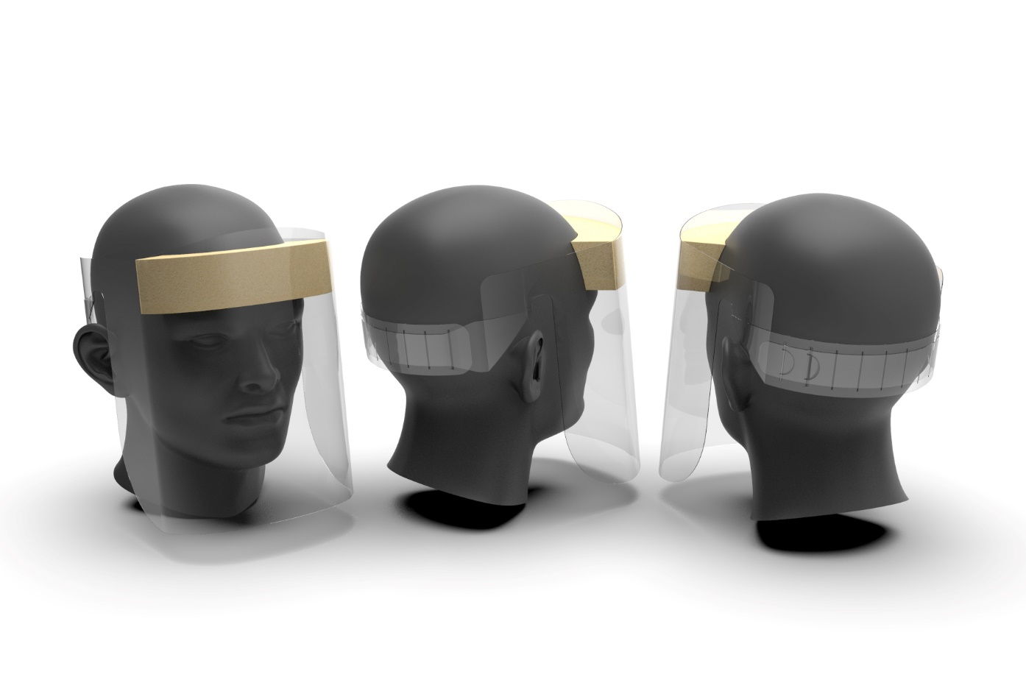
The Staeger Face Visor incorporates two components, 240um recycled PET and a medically approved piece of Foam, size 150 length x 40mm width x 30mm depth. The Foam is not known to cause skin irritation when in contact with the wearer of the eye-protector.

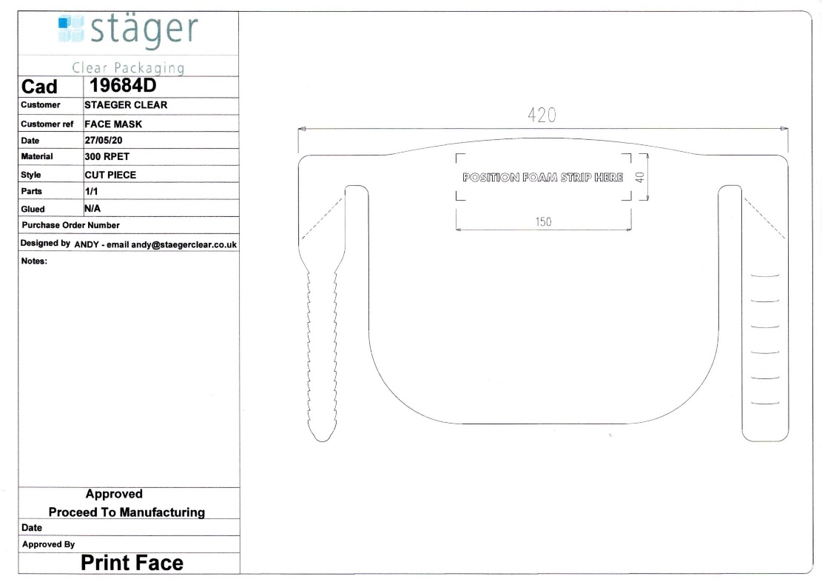

Component Specification:
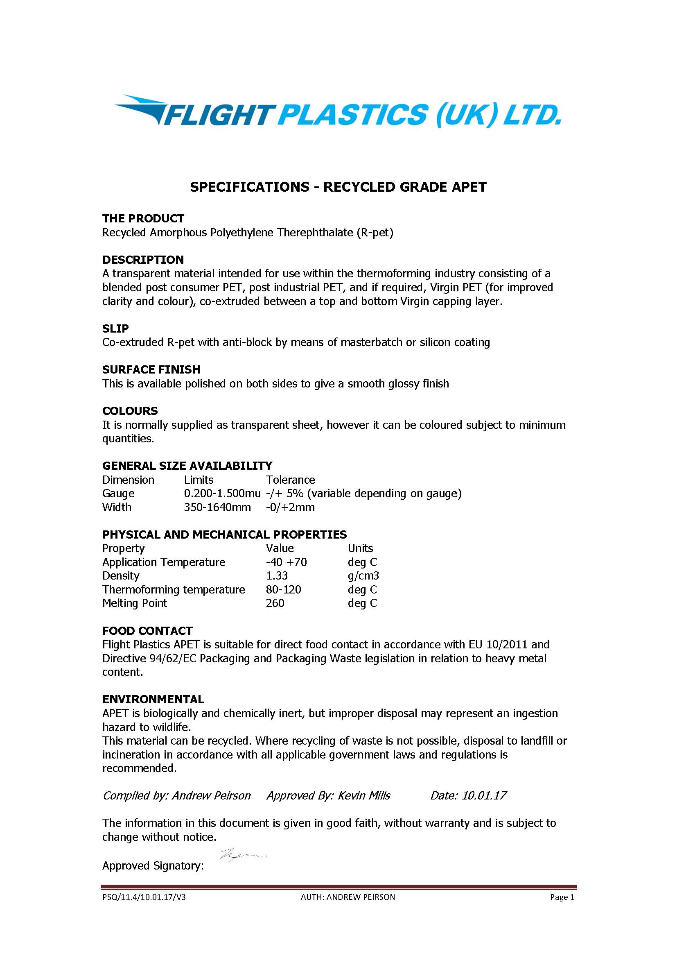

Declaration of Conformity
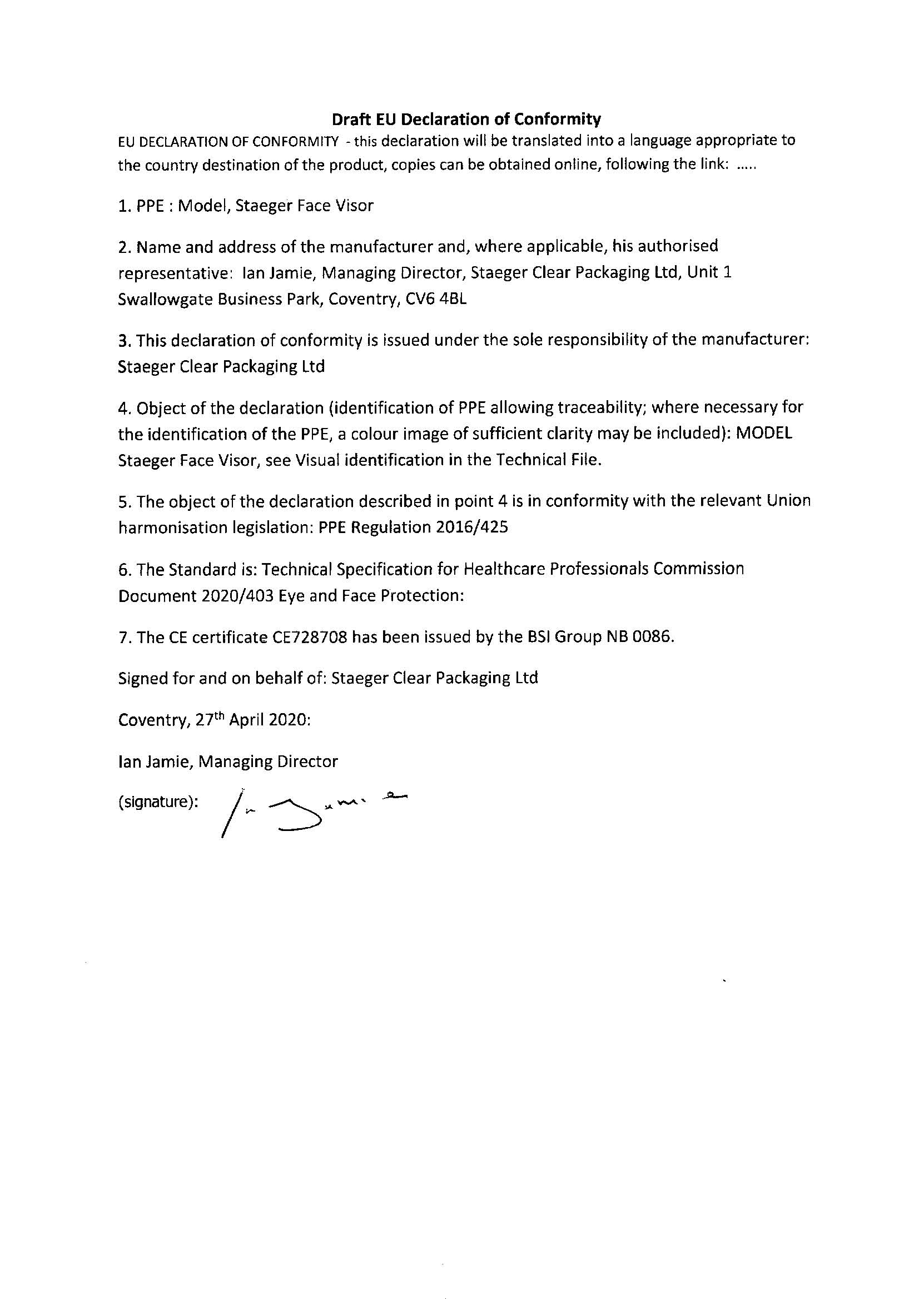

Marking: CE shall be placed on the product as well as the model designation. CE 728708, Staeger Face Visor.

User Information:
Staeger Face Visor produced by:
Staeger Clear Packaging, Unit 1 Swallowgate Business Park, Coventry CV6 4BL.
To protect against the ingress of Covid-19 virus into the face.
The protective Faceshield/Visor is manufactured for Covid-protection only. This filtering Faceshield/Visor is not a PPE device for general use and shall not be used for purposes other than protection against COVID-19.
The Staeger Face Visor is a single use product and should be disposed of at the end of the shift.
The Staeger Face Visor conforms to BSI’s PPE for Healthcare Professional 2020/403 /Eye protection.
The examining body was BSI, Kitemark Court, Davy Avenue Knowlhill, Milton Keynes, MK5 8PP, NB number 0086

